THF-M
High Frequency Spindle with collet
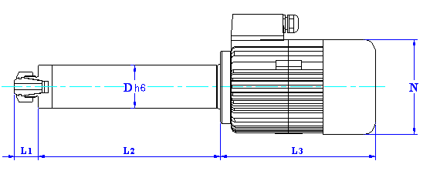
Spindle type | Dimensions mm |  |  |  |  | Collet |  | Motor
Spindle type | D | N | L1 | L2 | L3 | Type | z | pole | Weight
THF-40M | 40 | 102 | 22 | 180 | 143 | ER-16 | 1~10mm | 2 | 4.1 kg
THF-50M | 50 | 110 | 25 | 215 | 180 | ER-20 | 2~13mm | 2 | 6.8 kg
THF-70M | 70 | 135 | 27 | 270 | 210 | ER-32 | 3~20mm | 2 | 16kg

Electrical specifications
THF-40M | Point1 | Point2 |  |  | THF-50M | Point1 | Point2
N | 27000 | 36000 | RPM |  | N | 18000 | 30000 | RPM
F | 450 | 600 | Hz |  | F | 300 | 500 | Hz
Ps1 | 0.8 | 0.8 | Kw |  | Ps1 | 1.1 | 1.1 | Kw
U | 220 | 220 | V |  | U | 220 | 220 | V
I | 3 | 3 | A |  | I | 4.2 | 4.2 | A

THF-70M | Point1 | Point2
N | 18000 | 24000 | RPM
F | 300 | 400 | Hz
Ps1 | 2.3 | 2.3 | Kw
U | 220 | 220 | V
I | 8.0 | 8.0 | A

