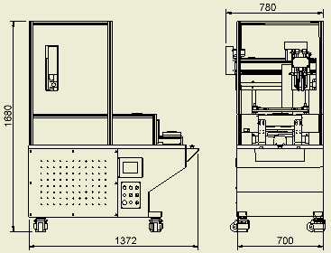

Type | FC–10U-R
Power | 3PH 220 V60 Hz/380 V50 Hz
Consumption | 1.2KW
X-asis gluine stroke (mm/max) | 400 mm
Y-axis gluing stroke  (mm) | 500 mm
Laminating stroke  (mm) | 300 mm
Air pressure | About 6kg/cm^2 ± 1kg/ cm^2
Net plate size  (mm) | (內)300mmX200mm / (外)350mmX250mm
Reticulation | 80-100mash
Fixture size(mm) | (L)200mm X (W)150mm X (H)20mm
Weight | 520kg

※The above specifications, dimensions, color reference, manufacturers have the right to change on our own, and subject to change without notice.

